* **Synopsis for Smart Mirror Project in CPP**

**Project Title: Smart Mirror: Personal Assistant for daily Life.**

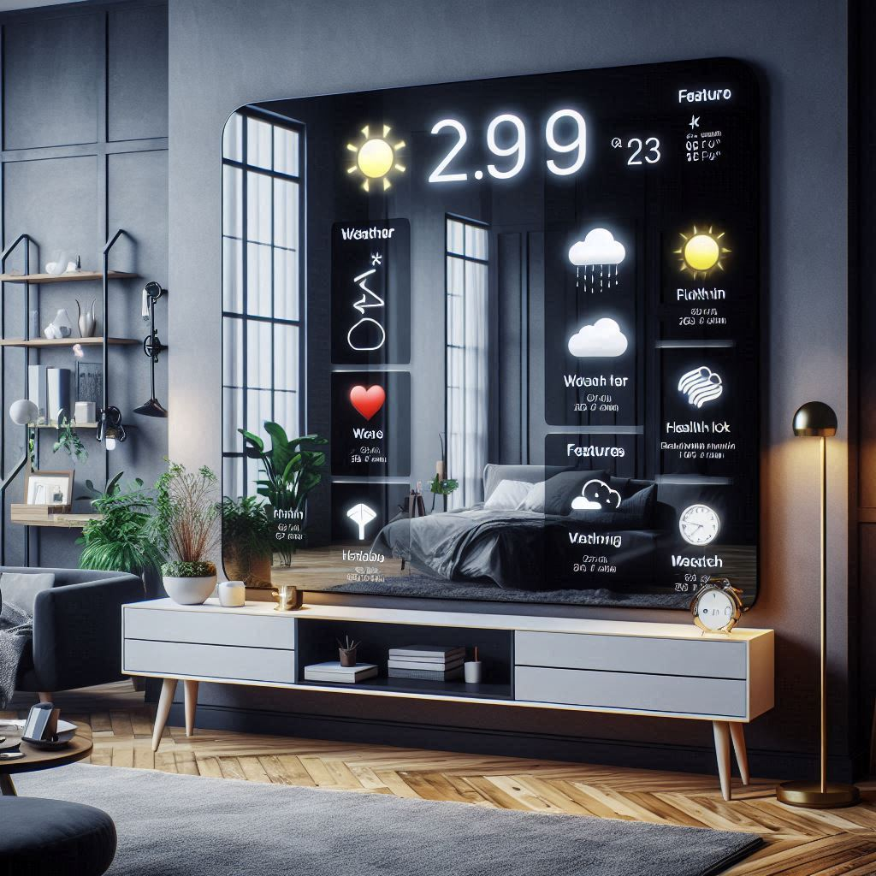

* **Objective:**

The purpose of this project is the creation of an interactive smart mirror that not only serves as a reflective device but also provides users with real-time information relating to time, weather, news, health detail and personal notifications. Therefore, the smart mirror serves in accordance with the necessity of generating user convenience through multiple functionalities combined into one device.

* **Main Features:**

1. Live Clock and Date: It shows the time and date of what is happening at present.

2. Weather News: The application fetches live updates and weather news from the location of the user.

3. News: Provides users with the latest headlines of selected news sources.

4. Calendar and Reminders: All the calendars of users are integrated into the application to show upcoming events and reminders.

5. Health detail: It can be integrated with health devices to display vital statistics, such as blood pressure, heart rate or weight. (such as example a blood pressure monitor) .

6. Voice Command Functionality: Users can use voice commands to interact with the system to control it hands-free.

**Technical Requirements:**

* **Hardware:**

o Two-way mirror

o Display monitor (HD)

o equivalent PC

o Optional: Webcam, microphone and speakers for further interactions

* **Software:**

o C++

o C++ for graphics and some use of html.

o Integrations of API for live data: weather, news, calendars

* **Implementation Plan**

1.

Research Phase: Identify the existing projects on smart mirrors. Note the strength points and weaknesses

Hardware Assembly: Prepare the frame to assemble the monitor with a two-way mirror.

Software Development:

Write the core application in C++.

Develop an interface that is easy to navigate .

Implement APIs to fetch the data for the weather and calendar.

4. Sensing and Iteration: Conduct tests to find all bugs and feature problems without any conflict with the user, improve based on users feedback.

5. Deployment: Deploy the smart mirror finally, acquire perceptions from users to enhance the intelligent mirror in the subsequent versions.

* **Expected Outputs**:

• Fully working intelligent mirror that much has improved the convenience for the user as well as its interaction.

• An aesthetically beautiful and user-friendly smart mirror interface which the user finds easy to use and interact with.

•A detailed documentation report which would effectively communicate all steps taken, issues faced, solutions offered and all user feedback.

•A full health detail with increasing height and weight and hearthrate.

* **Methodology:**

•Literature Review: Research on available technologies and design concepts of smart mirrors.

•User-Centered Design: Engage users at the early stage of design to know what users exactly require and like.

•Agile Development: Tackle the software development process with iterative development to improve continuously based on the results of testing and user feedback.

* **Technologies:**

•Programming Languages: Mostly C++ but in few web-based units, HTML/CSS might be used.

• Frameworks: Use Qt framework for the development of strong GUIs.

•  APIs: Use REST APIs for weather, news, and calendar live feeds.

* Conclusion:

The project on the smart mirror is so touching when it comes to touching the point where technology meets convenience in daily life. The objective of this project is to convert a simple item into a powerful personal assistant. This project is expected to change many daily routines and will also gain highly worthwhile experience with the application of IoT and smart technology if hardware and software components are well-integrated.

------------------------------------------------------------------------------------------------------------------------

**Name: Ashish Chavanke**

**PRN: 2124UCSM1017**

**Department of Cyber security**.